现代化汉教中心HSK报考表
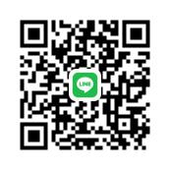
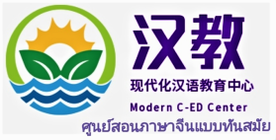
HSK Test Application form * ใบสมัครสอบ HSK จาก MOCED
Test Application date 报考日期: ＿＿＿＿＿ NO:＿＿＿
基本信息  B  A  S  I  C  I  N  F  O  R  M  A  T  I  O  N | ชื่อภาษาอังกฤษ  English Name |  | 性别  Gender |  | 出生日期  Date of Birth |  |  |  | 清晰证件照  Clear Photo
 | 中文名 /  Chinese name |  | 婚否  Marital status |  | Nationality  国籍
 | 身份证□ / 护照□ 号码  No. of ID□ / Passport□ |  |  | 联系电话  Tel. No.
 | 瞬时联系  Contact Online | LINE：  WeChat:  QQ: |  | E-Mail
邮寄地址
Mailing Address
学习中文多少年/月？
How long have you learned Chinese?
 | 考级  TEST LEVEL  （备注：报考费率是全球统一的。  我们凭籍对推广汉教事业竭诚之爱，为你免费办理HSK正式报考手续，并接受相关事项的免费咨询。）  (Remark:  The test fee rate is globally unified.  With the sincere love on Chinese education, we will proceed the official HSK registration for you, and offer you relevant consultant service for free.) | 类别 Type 级别 Level 泰铢 Baht 选择考级 Choose exam level  HSK (paper test) HSK 1 500+60  HSK 2 700+60  HSK 3 900+60  HSK 4 1,200+60  HSK 5 1,600+60  HSK 6 2,000+60  HSKK (Spoken test) 初级口语 Primary Oral Chinese 500+60  中级口语 Intermediate oral Chinese 700+60  高级口语 Advanced oral Chinese 800+60  YCT 少儿中文 YCT level 1 100+60  YCT level 2 200+60  YCT level 3 300+60  YCT level 4 400+60
 | หมายเหตุ | 1.务必用中文或英文填写表格 Please fill in the form in Chinese or English。  2. 成绩邮寄费为60铢，The mailing fee of test result is 60 Baht.
上表填写完整后，请回传到邮箱E-mail: moced22@gmail.com 欲咨询更多详情，请联系 MOCED。
Please send back your fully filled application form to the E-mail: moced22@gmail.com
Getting more details via website: www.moced-center.com / Facebook: Modern C-ed
Line: MOCED22 / WeChat: MOCED1 /

